**Babylon Payment Automation System (BPAS)**

**For brochure:**

1. Babylon Payment Automation System (BPAS) is a simplified system which allows user to create ‘work orders’ for vendors and track all kinds of submitted bills/invoices against the work order to avoid undesirable situations i.e. (bill missing/ submitted double bill/ delay payment.)

Users can create ‘purchase order’ more accurately from different units by concern procurement departments which will be shown to the central office users for tracking and processing purposes, which means that this system is design in a way that a master company (corporate office) users can access all units’ purchase orders.

**Core Features:**

1. Purchase Order Creation
2. Supplier Invoice Entry & Barcode Generation
3. Supplier Invoice Tracking In Departments
4. Payable Calculation
5. Audit Feedback
6. Cheque Preparation
7. Cheque Disbursement

**Benefits:**

* Traceability - Fast & Secure Invoice/ Bill Processing
* Real-Time Visibility in to Invoice Processing
* Avoid Invoice Duplication & Follow Up Late Payment
* Reduce Invoice/ Bill Missing Possibility,
* Improvise Customer Vendor Relationship
* Easy Cheque Preparation
* Standard Procedure And Receipt Acknowledgement From Vendor During Cheque Disbursement
* Minimize Cost & Time Saver
* Easy Integration With 3rd Party Applications

**Role Wise Sub Key Features:**

**Procurement**

* Unit wise purchase order entry.
* Unit wise Purchase Order and Approval
* Good received Confirmation Date Entry
* Purchase Order Report (Draft/Actual).
* Unit wise PO Report.

**Admin**

* Organization Profiling
* Department Profiling
* Bank Profiling
* Bank Account Profiling
* User Profiling

**Helpdesk**

* Invoice Scan
* Invoice Entry.
* System Generated Bar Code.
* Supplier Acknowledgement Slip.
* Real-time Invoice Tracking
* Non-Purchase Order Create.
* Cheque Disbursement
* Cheque Disbursement slip

**Central Procurement**

* Invoice Scan
* Purchase order entry for all Unit.
* Good received Confirmation Date Entry for all Unit.
* Invoice Amount Change request
* Purchase order Approval for all Unit
* Generate PO Report for all Unit.

**Invoice Amount Editor**

* Invoice scan
* Change Invoice amount

**Finance**

* Invoice scan
* Invoice Amount Change request
* Invoice VDS & TDS calculation.

**Audit**

* Invoice scan
* Invoice Amount Change request
* Auditor comments
* VDS & TDS Reconcile Request
* Payable Rejection Request

**Treasure**

* Invoice scan
* Cheque Preparation (Single/Multiple Invoice)

**Few Screen 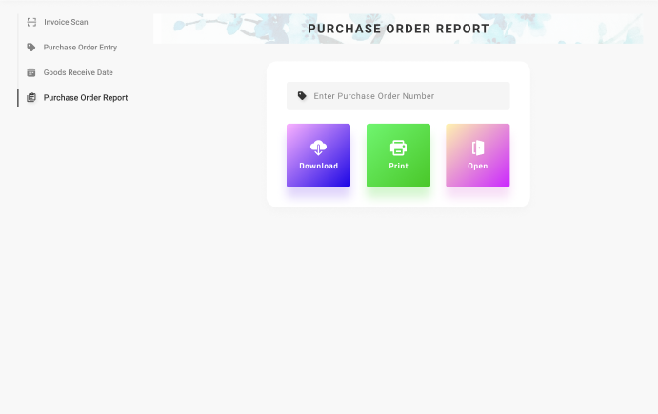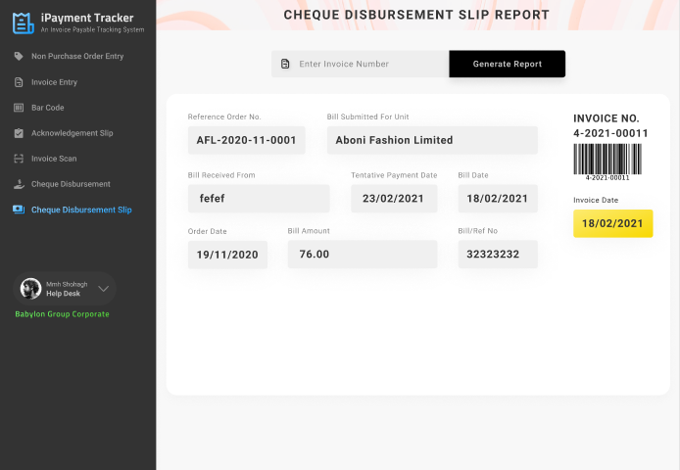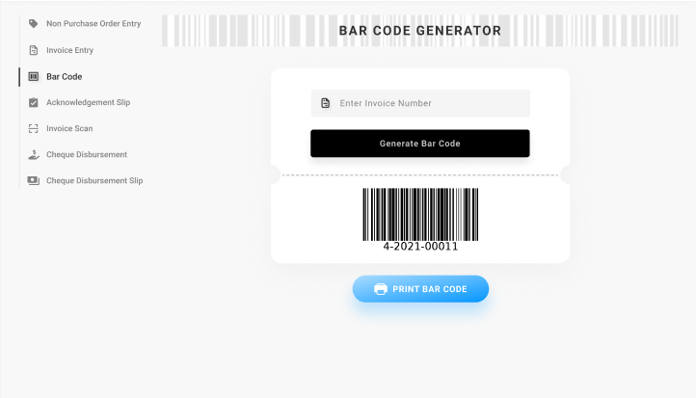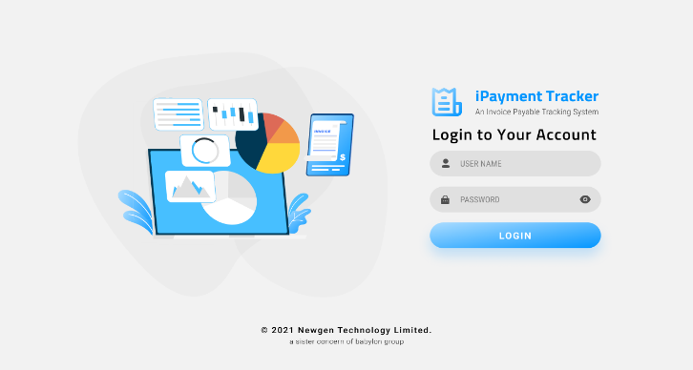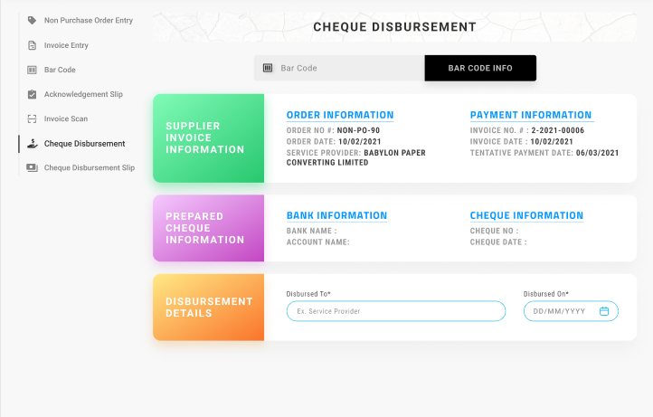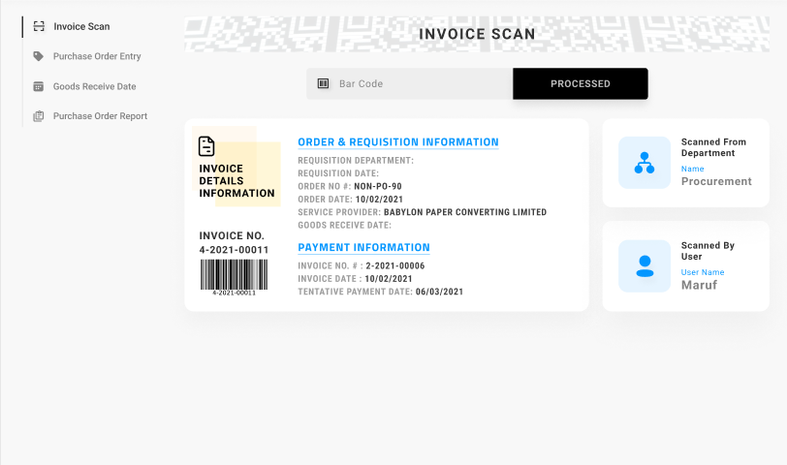Shots of BPAS**

**Contact Us:**

Ph: 88 (02) 8032949, 01309366028

About Newgen

Newgen Technology Ltd. is one of the leading and fast moving tech companies in Bangladesh, works on different frontier technologies and developing latest solutions. It provides ERP solution, SaaS and customized software for local and global market. Newgen Technology Ltd. also provides training and consultancy services to its clients and execute projects on a turn-key basis.

• 100+ Expert Recourses

• Highly Productive Office Environment

• International Standard Training Lab

• 1000+ Implementation

• 500+ Clients

• 24/7 Customer Support

**For Flyer:**

Babylon Payment Automation System (BPAS) is a simplified system which allows user to create ‘Work Orders’ for Vendors and track all kinds of submitted bills/invoices against the Work Order to avoid undesirable situations i.e. (Bill missing/ submitted double bill/ delay payment.)

Users can create ‘Purchase Order’ more accurately from different Units by concern Procurement Departments which will be shown to the Central Office users for tracking and processing purposes, which means that this system is design in a way that a Master Company (Corporate Office) users can access all Units’ Purchase Orders.

**Core Features:**

1. Purchase Order Creation

2. Supplier Invoice Entry & Barcode Generation

3. Supplier Invoice Tracking In Departments

4. Payable Calculation

5. Audit Feedback

6. Cheque Preparation

7. Cheque Disbursement

**Benefits:**

* Traceability - Fast & Secure Invoice/ Bill Processing
* Real-Time Visibility in to Invoice Processing
* Avoid Invoice Duplication & Follow Up Late Payment
* Reduce Invoice/ Bill Missing Possibility,
* Improvise Customer Vendor Relationship
* Easy Cheque Preparation
* Standard Procedure And Receipt Acknowledgement From Vendor During Cheque Disbursement
* Minimize Cost & Time Saver
* Easy Integration With 3rd Party Applications

**Contact Us:**



Ph: 88 (02) 8032949, 01309366028